SQL Server Express Introduction 1
Logging in to Management Studio Express 1
Creating a New Database 2
Creating a New Table 4
Creating Columns 4
Adjusting Column Properties 4
Setting Primary Keys 4
Creating the ER Diagram 6
Entering Data 8
Querying Your Data using SQL 9
Query A: Selecting all data in your database 10
Query B: Selecting customer information with all orders 10
Individual Exercise 11

SQL Server Express Introduction
This document provides a brief introduction to some of the features that can be used for designing and maintaining a database.

Logging in to Management Studio Express
To launch SQL Server Express, from the start menu, select Programs | Microsoft SQL Server 2005 | SQL Server Management Studio Express. This will launch your Connect to Server dialog. The server name should already appear in the Server Name dialog. If it doesn’t, you should be able to select it from the Server Name dialog. I am using the SQL Server Authentication to use the administrator that was created during the install. The login name is sa by default and the password is the one that was set during the install. For me, this password is Abc123. Login info for the lab will be provided.
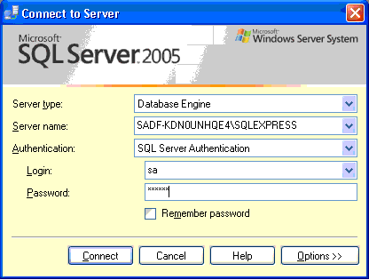

Creating a New Database
Once you have entered your login information click Connect. In Management Studio Express, you can create your own database using the graphical interface. This can be done from the Object Explorer. Right clicking the Databases folder will allow you to choose New Database.
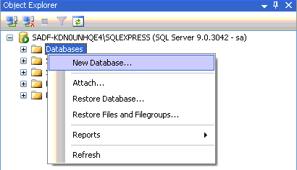

When you click New Database you can then enter in the database name in the New Database dialog. In this case, the name is MyDB.
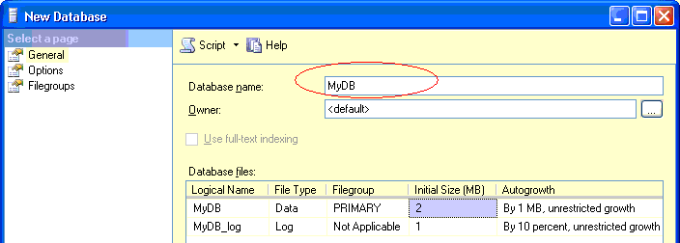

Once you have finished entering the name, click OK to generate the new database. Your new database should now exist in the Object Explorer.
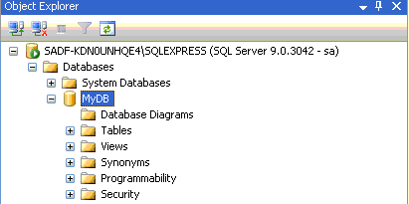

Creating a New Table
You can create a table by right clicking the Tables folder and choosing New Table in the drop down that appears. This will launch a table design window shown on the left and a properties window shown on the right in the following image. If the Properties Window does not appear, you can make it visible by selecting Properties Window from the View menu.

Creating Columns
When doing this exercise, create a table that uses your name for the customer table. Notice how CustomerID and CustomerName are not permitted to be NULL.
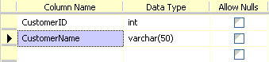

Adjusting Column Properties
For the CompanyName column, change varchar length to 100 to allow the CompanyName to have up to 100 characters. This can be done in the ColumnProperties window that appears below the table design view. The Column Properties for CompanyName will appear below if you select this column by clicking it with the mouse cursor in the table designer.
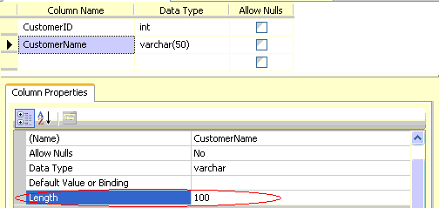

Setting Primary Keys
You can set the primary key by right clicking the column(s) and choosing Set Primary Key.
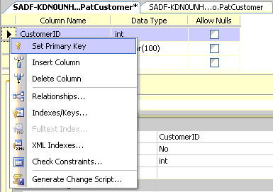

Your finished result should look like this:
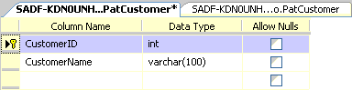

Once you have your customer table set as shown above you can save it by clicking the Save All icon.


Repeat these steps to create and save a CustomerOrder table. (Order is a reserved word in SQL so the table will not be called Order).
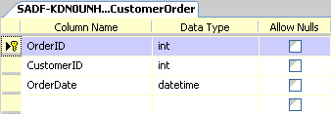

Once the tables have been created, they will appear in the Object Explorer.
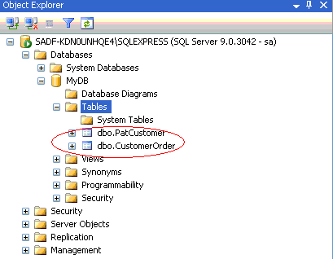

If you want to edit these tables later in the graphical designer again later on right click the table and choose Design.

Creating the ER Diagram
When your tables have been created, you can create an ER diagram with them. It is wise to do this of course while designing your database and also it is wise to do this later for enforcing referential integrity.

The ER diagram tool is launched by right clicking the Database Diagrams folder under your new database icon. Once you are there, select New Database Diagram to create a new ERD.

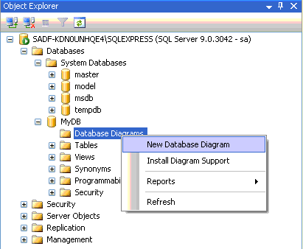

During the first run, you will be prompted to install the ER Diagram tool. When prompted click yes.
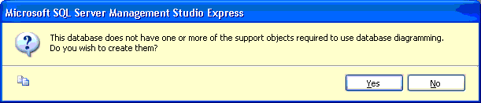

In the next step you will be asked to add tables. For this example, select both tables and click Add.
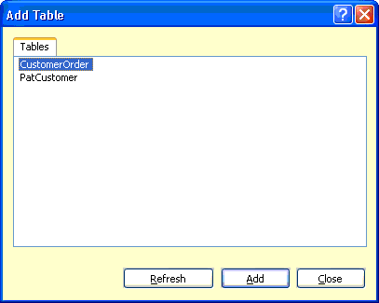

The ERD will now appear with both entities.
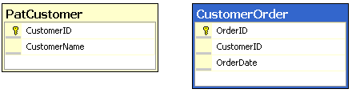

You can create a relationship between the PatCustomer entity and CustomerOrder entity by left clicking the CustomerID colum in the PatCustomer table and dragging the mouse cursor to the CustomerID column in the CustomerOder table.

A couple of dialogs will appear which are fairly self-explanatory. Here you can specify whether or not you want to apply any changes to related tables during updates or deletes to the primary table. The cascade option enforces this.
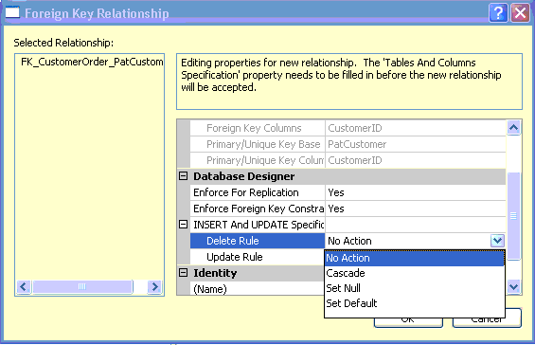

After clicking OK, your tables should now be related. You can see this is a 1 to many relationship by viewing the key and infinity icons respectively in the relation.
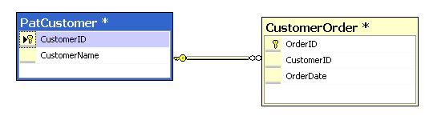

Entering Data

Entering data into your tables using Microsoft SQL Server Management Studio Express is simple. This can be done by right clicking the table name in Object Explorer and choosing Open Table from the drop down. This will launch the data views shown in the images below where you can enter in your own data. Enter some data and also include your name for one of the customer names.

Here is some data entered in SQL Server Management Studio for the Customer and CustomerOrder tables.
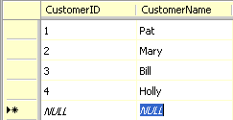

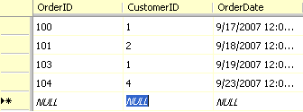

Querying Your Data using SQL
SQL (pronounced sequel) is structured query language. This language is very similar for most mainstream databases and can be used to maintain and view your data. In large enterprise database operations, knowledge of SQL is vital. This topic will be visited later in more detail.

SQL can be entered, edited, and executed from the Database Engine Query panel. You can open it from Management Studio Express by selecting the Database Engine Query icon underneat the menu of SQL Server Express.

When you select the icon, you will be prompted to login again even though you have logged into Management Studio Express. Once again your default login is sa and your password is whatever you chose during the install. (Mine is Abc123)
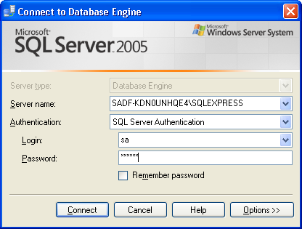

Click Connect once you have entered your authentication information to view the SQL editor.

To be sure that the SQL you write is going to be applied to your database, make sure that you select your database.
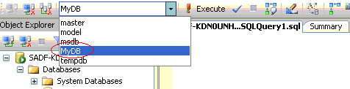

Now you can start running queries on your database.

Query A: Selecting all data in your database
Here is one that selects all data in the customer table.

After you type in your SQL, you can run it by clicking Execute. The results will appear below.
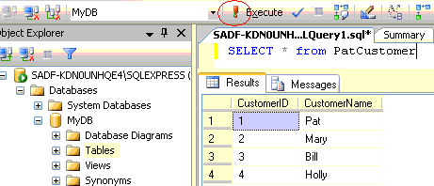

Query B: Selecting customer information with all orders
This query shows how to display all order numbers and associated customers:

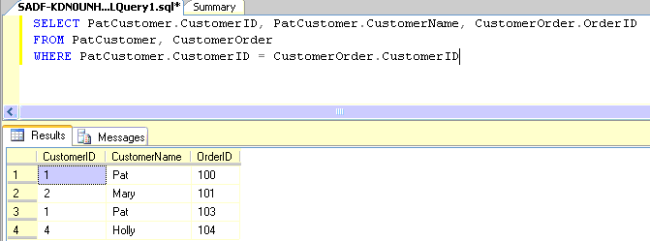

Individual Exercise
This exercise is to be done by you only due by the end of class.

Submit these items in one message to your private discussion folder. Please label it clearly in the subject line as *week3 SQL Server Intro*:
- A screenshot of the An ER Diagram that you created for the demonstration in this document using SQL Server Express 2005.
- A screenshot of your customer table data where you entered it from SQL Server Express. Make sure that the customer table name is preceded with your first name.
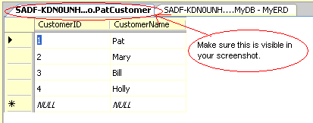
- Create an SQL query to pull all orders and view associated data in the customer table. Take a screenshot of your query in Database Engine Query and also include the results in this screenshot.

